**UML DIAGRAMS**

**USE CASE DIAGRAM**

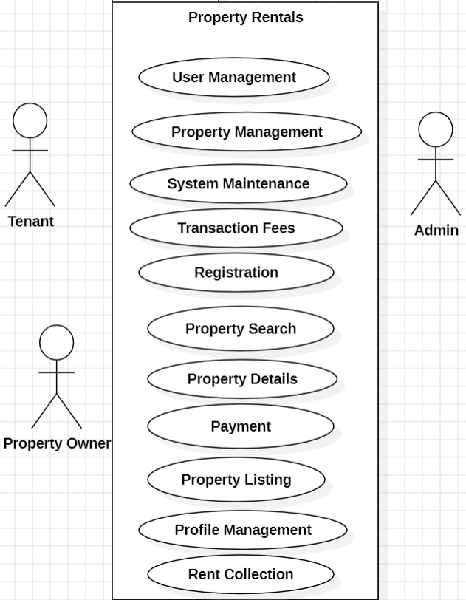

**SEQUENCE DIAGRAM**

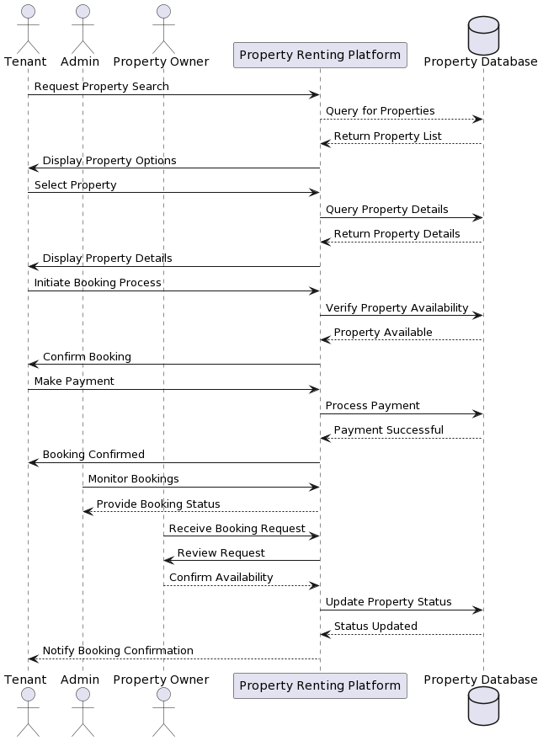

## STATE CHART DIAGRAM

## 

**ACTIVITY DIAGRAM**

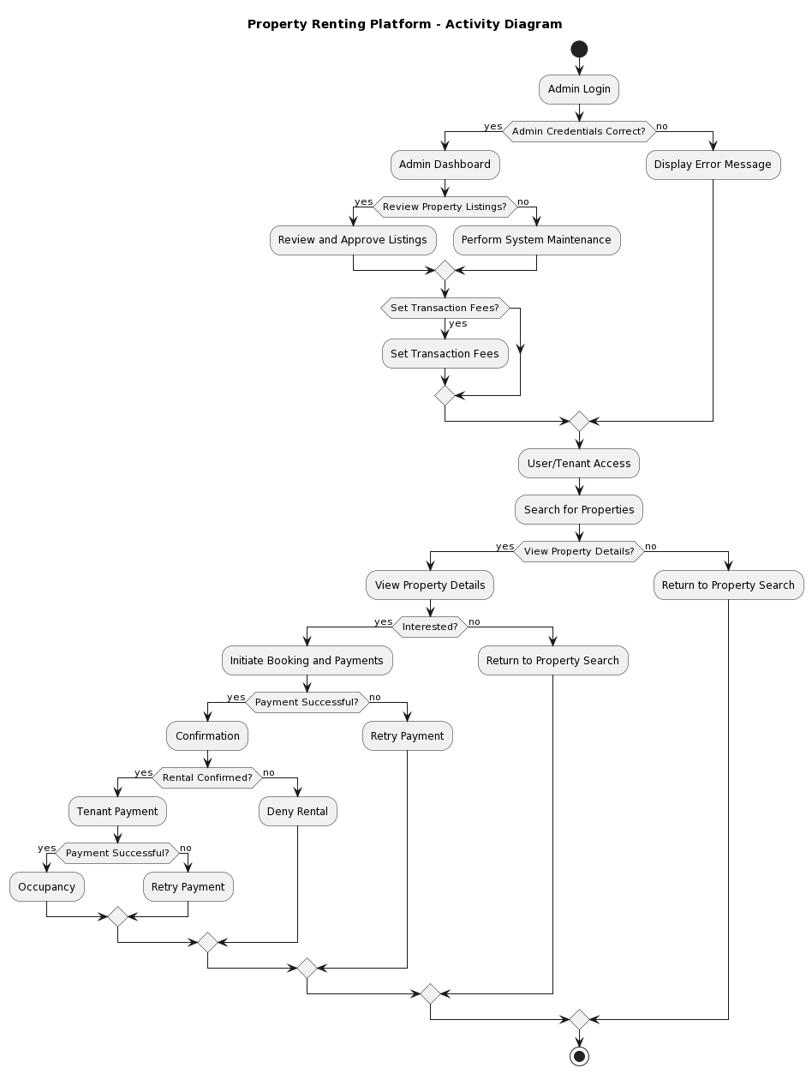

**CLASS DIAGRAM**

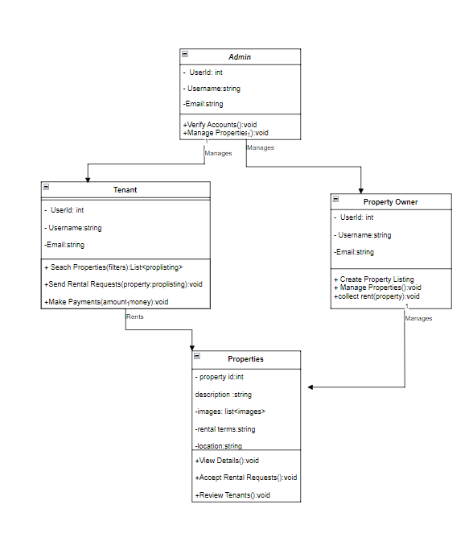

**OBJECT DIAGRAM**



**COMPONENT DIAGRAM**

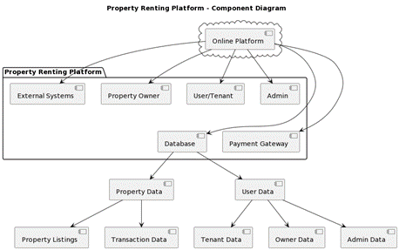

**DEPLOYMENT DIAGRAM**

